**Steps taken to final product.**

Table of contents:

**Finding errors and cleaning 2**

Errors 3

**Pivot Tables 5**

Pivot table 1 6

**Interactive Dashboards 6**

# 

# 

# 

# **Finding errors and cleaning**

First I want to organize and clean the dataset. To do this I freeze the top panel and add a filter and find the function of excel.



Next I want to find clues on where potentially errors could occur. Typically in excel CSV files these errors are input errors or string errors. So I sort from largest to smallest and vice versa to see if there are any sales data that says £0 or #REF or NaN to proceed.

From largest to smallest

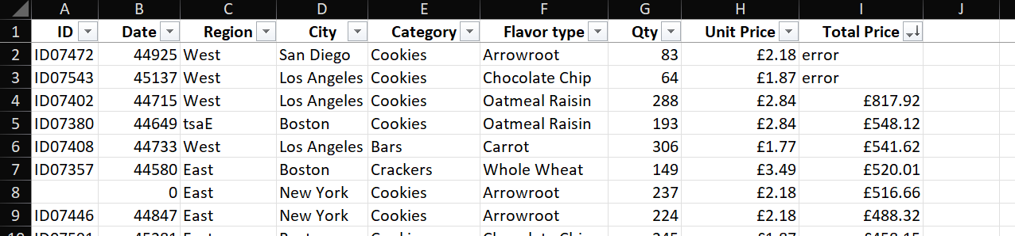

From smallest to largest

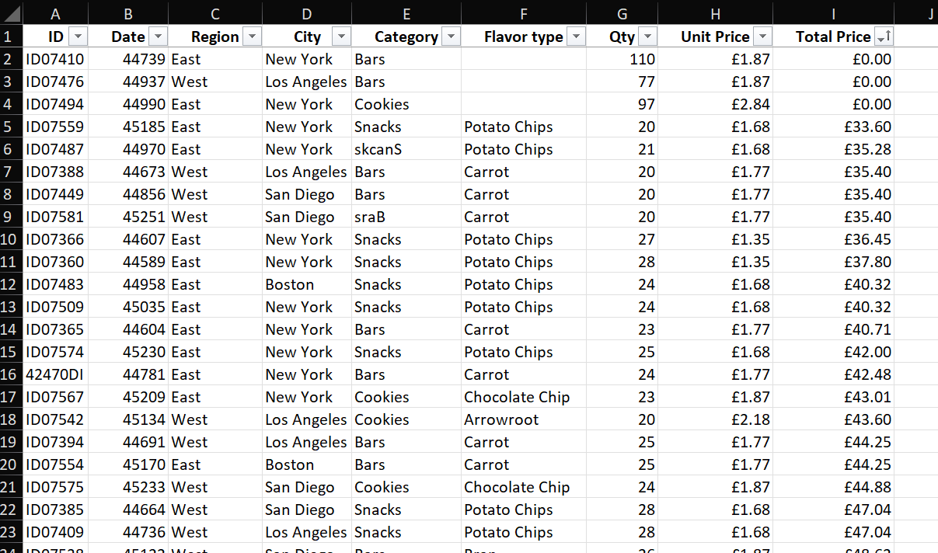

Already we can see many input errors and mistakes that we need to clean up.

## Errors

Next I would filter out the £0 and the error exclusively:

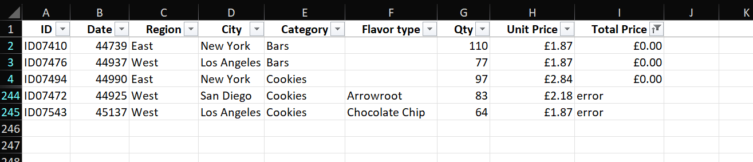

We then can send these to the data engineering team for further inspections. But for the simplicity of this exercise we will be eliminating these data points.

Next I would repeat the filtering process for the remaining header types and look for anomalies. The following errors are as follows: Unit price, Quantity, Flavor type, Category, Cities, Region, Date, IDs respectively.

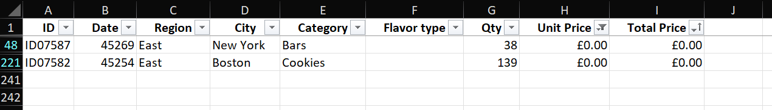

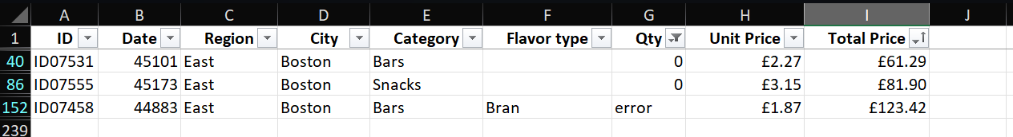

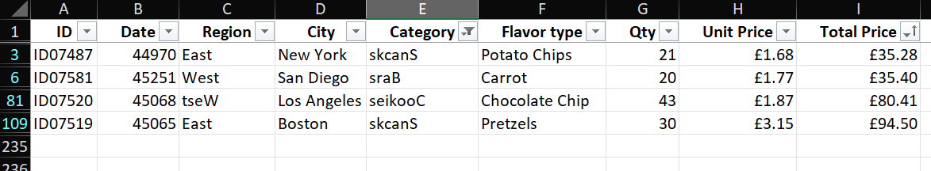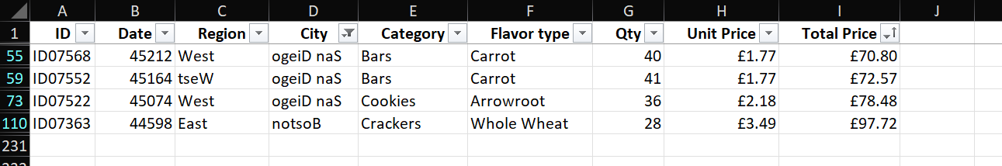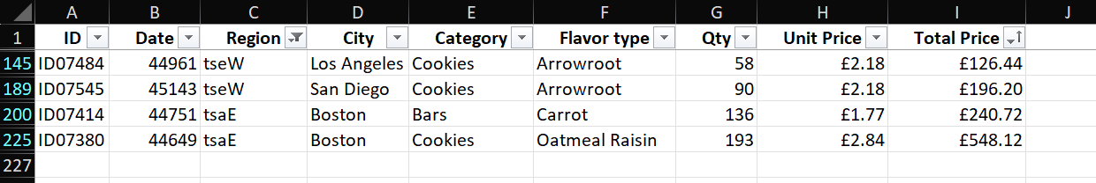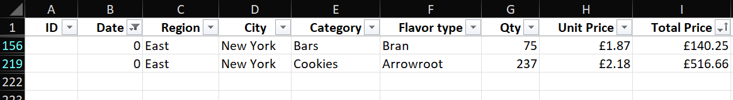

Following this, the cleaned version is listed in the github repository as Foodsalesdata_Version_1

# 

# **Pivot Tables**

The next step is to create pivot tables and interactive dashboards for the stakeholders of said company.

First we need to ensure the excel is in a table format. (Ctrl+T once selected all datapoints)

(Ctrl+shift+ down arrow to select all)

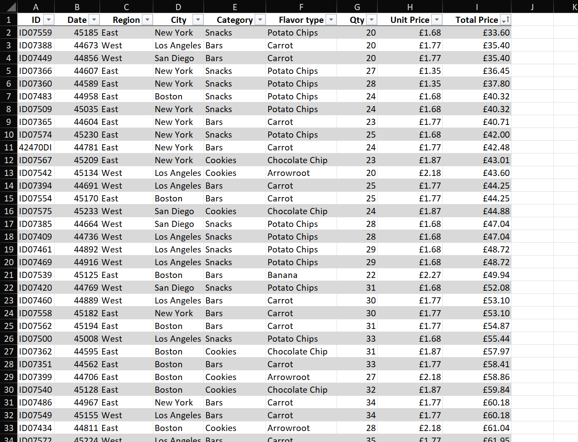

The excel should look like this now.

For this specific project I will be using 3 pivot tables to create the dashboards.

## Pivot table 1

For the first pivot table I wanted to find which flavor type is the most profitable and which city garners the most sales. Dragging the city to the row section and flavor type to the column section, and finally total price (total revenue) in the Value section.

I then sort largest to smallest for both the column and rows of grand total.

We now know Boston and Oatmeal Raisin is the highest grossing city and product we have.

## Pivot table 2

Applying the same principle we can find revenue by category type according to regions.

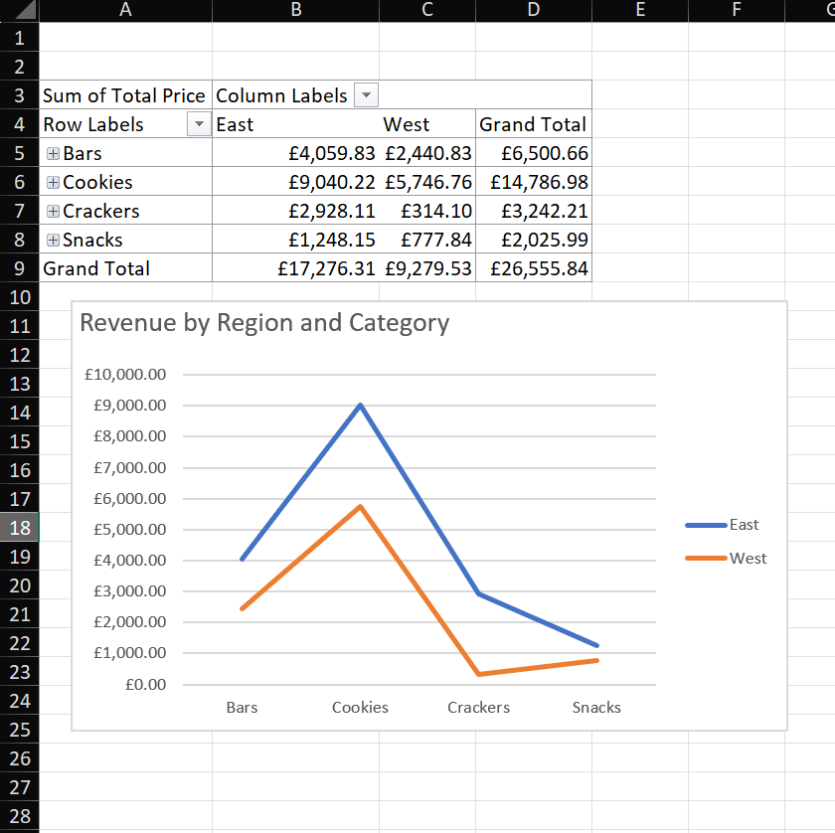

# **Interactive Dashboards**

We can now copy the previous pivot table’s pivot chart onto our dashboard sheet.

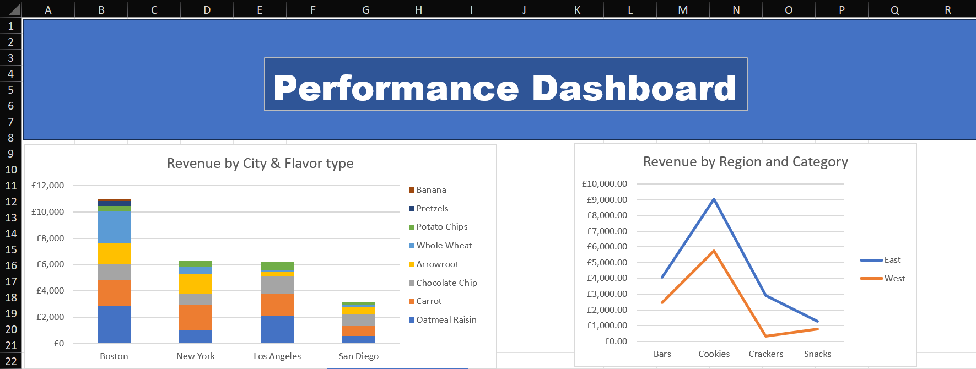

Clicking onto each one allows you to select the pivot chart analyze section of excel.

You can then add slicer to make the visuals interactable and finish off the interactive dashboard.

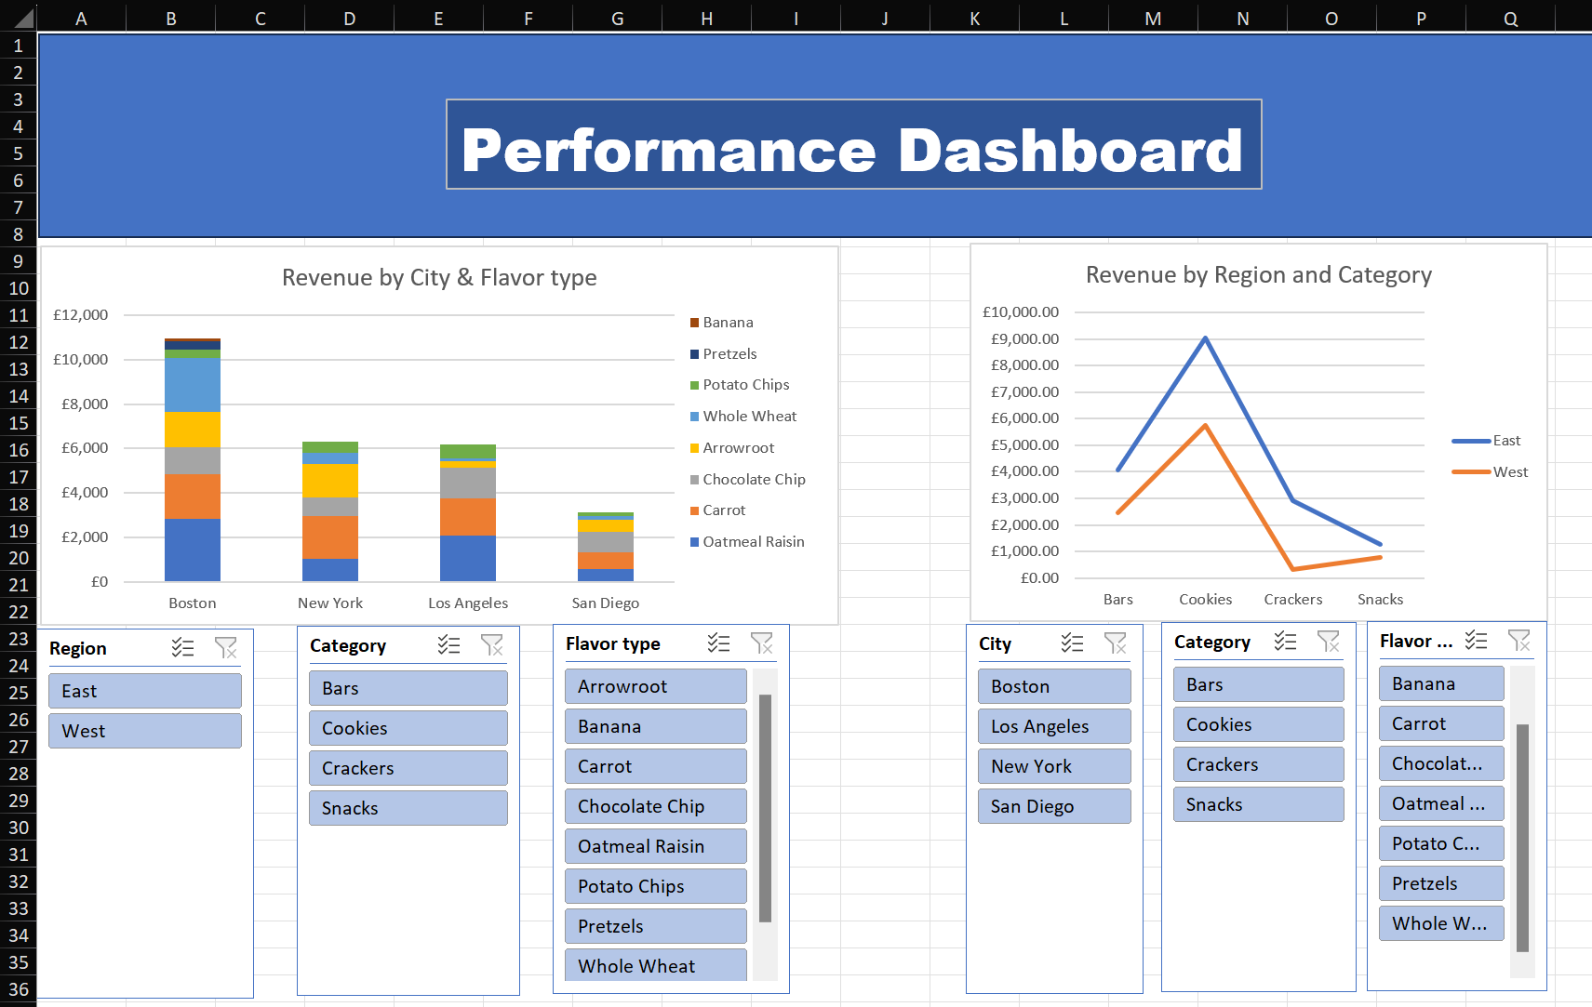

This will be the final product of this exercise.

The final version of the excel can be found in Foodsalesdata_Version_2